Help Centre

What is Doc-Scribe

How Doc-Scribe.ai Works

Upload Your First Document

My Box vs Categories

Creating Categories

Using Collections

Metadata and Tagging

Interacting with Chat AI

Understanding AI Modes

Sharing Documents

Troubleshooting Common Issues

Choose Your Language

File Compatibility

User Access Control

- What is Doc-Scribe.ai
Doc-Scribe.ai is an AI-powered document intelligence platform that helps organizations manage, understand, and extract knowledge from their documents.
Modern organizations generate thousands of documents such as reports, policies, meeting minutes, contracts, and project records. These documents contain valuable knowledge that supports planning, analysis, and decision-making. However, finding the right information often requires employees to manually search through files, read large volumes of content, and compile insights—making the process slow and inefficient.
Doc-Scribe.ai transforms how organizations interact with their documents.
Instead of manually searching through files, users can ask questions directly to their documents using conversational AI. The system quickly retrieves relevant information, summarizes key insights, and delivers accurate responses in seconds.
In simple terms:
You no longer search your documents — you ask them.

- How Doc-Scribe.ai Works
Doc-Scribe.ai combines a Document Management System (DMS) with a private AI engine designed specifically for enterprise documents.
The platform allows organizations to:
- Store and organize documents securely
- Search documents using natural language
- Analyze documents with AI
- Extract key information automatically
- Generate summaries and insights instantly
The system reads your documents, understands their content, and allows you to interact with them through a chat-based interface
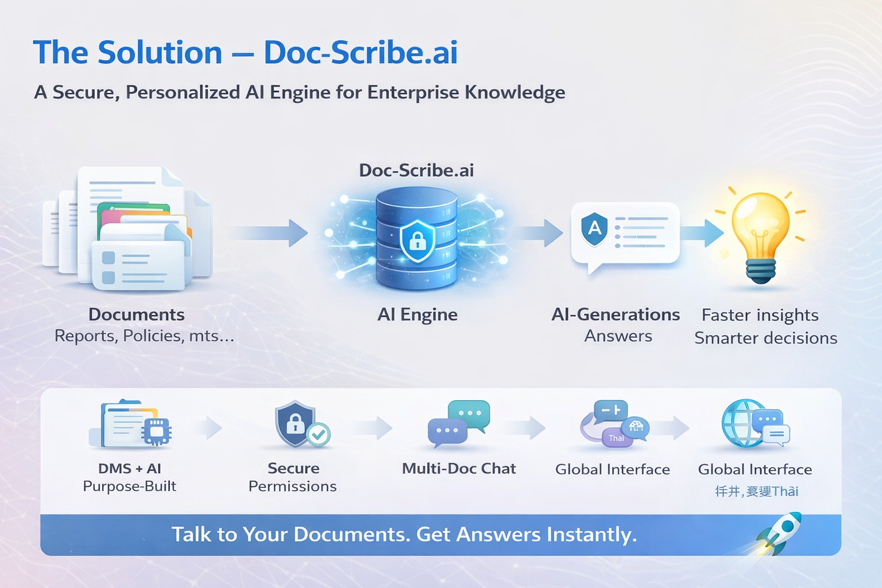

Key Capabilities
Doc-Scribe.ai provides powerful features to help teams work with documents more efficiently.

AI-Powered Document Intelligence
- AI search and document chat
- Instant document summarization
- Key data extraction
- Cross-document analysis

Secure Enterprise Platform
- Private AI environment
- Role-based access control
- Secure document sharing
- Permission-based data access

Multi-Document Interaction
Users can ask questions across multiple documents at the same time, allowing them to quickly find insights from large document collections.

- Upload Your First Document

Uploading a document is the first step to using Doc-Scribe.ai.

Steps
1. Click Upload from the navigation menu.
2. Choose the destination:

• My Box (private storage)
• Category (departmental storage)

3. Select a file from your computer.
4. The file moves to Staged Files.
5. Select the uploaded file.
6. Confirm the file category.
7. Click Upload Now.

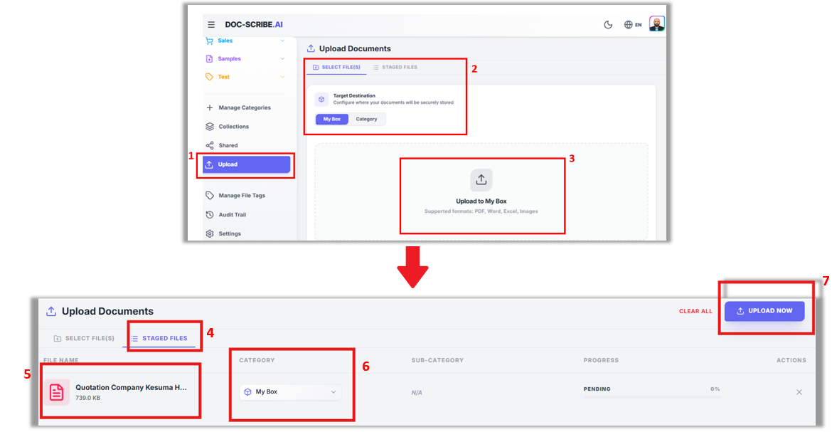

After uploading, the system automatically:
• Processes the document
• Extracts text
• Indexes the content
• Makes the document available for AI search

- My Box vs Categories

Doc-Scribe.ai provides two document storage environments.

My Box

My Box is your personal document space.

Files stored here are:
• Private by default
• Visible only to you
• Useful for temporary files or drafts

Example uses:
• Personal research
• Draft documents
• Private notes

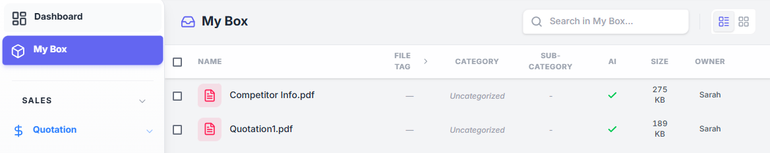

Categories

Categories are shared departmental folders.

Documents stored in categories can be accessed by other users within the same department.

Example:

Sales Department
• Quotations
• Price Book
• Competitor Information
• Tenders

Categories help organizations structure their documents for collaboration.

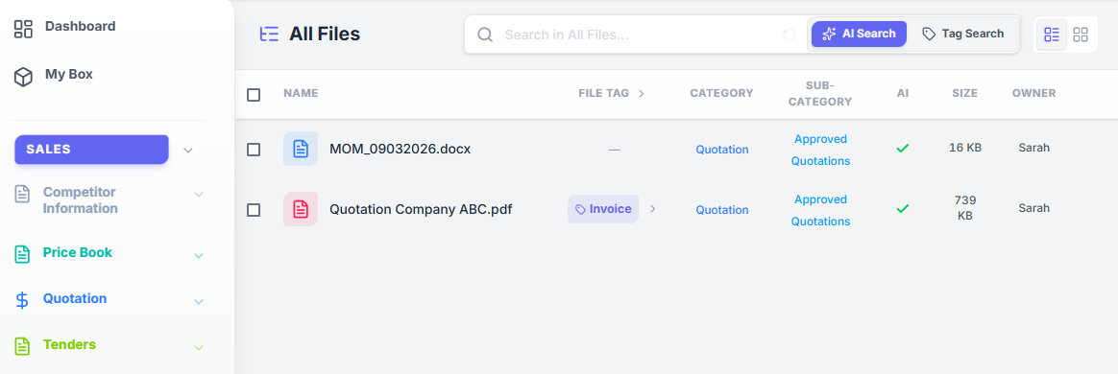

- Creating Categories

Categories help organize documents within departments.

Steps
1. Click Manage Categories from the navigation menu.
2. Ensure the Main Tab is selected.
3. Enter the Category Name.
Example:Quotations
4. Choose an icon and color (optional).
5. Click Create.

The category will now appear in the category list and can be used to organize documents.
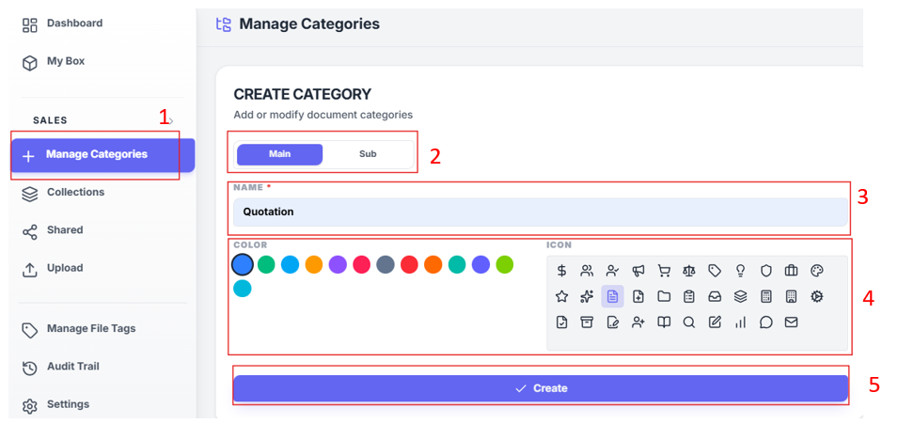

Your new category now appears in the list and is ready to use.

- Using Collections

Collections allow you to group documents from different categories into a single virtual workspace.

The original documents remain in their categories, but they can also appear in a collection.

Example:

Collection Name: Client Submissions

Documents may come from:
• Quotations
• Price Book

• Competitor Information
• Tender Documents

Collections make it easier to organize documents for projects or cases.

Creating a Collection
1. Click Collections.
2. Click New Collection.
3. Enter a collection name.
4. Click Create.

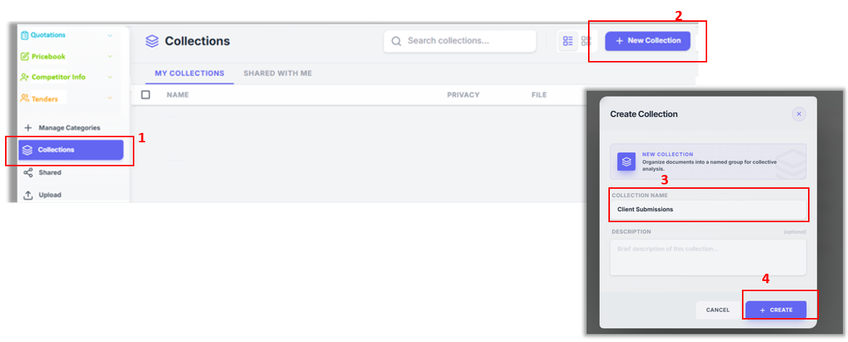

Adding Documents to a Collection
  - Click the Categories
Example : Quotation > Approved Quotation
2. Tick the document.
3. Click the Collections icon.
4. Select Existing Collections and choose a collection.
5. Click Add.
6. Navigate to Collections.
7. The new collection will appear in Collections

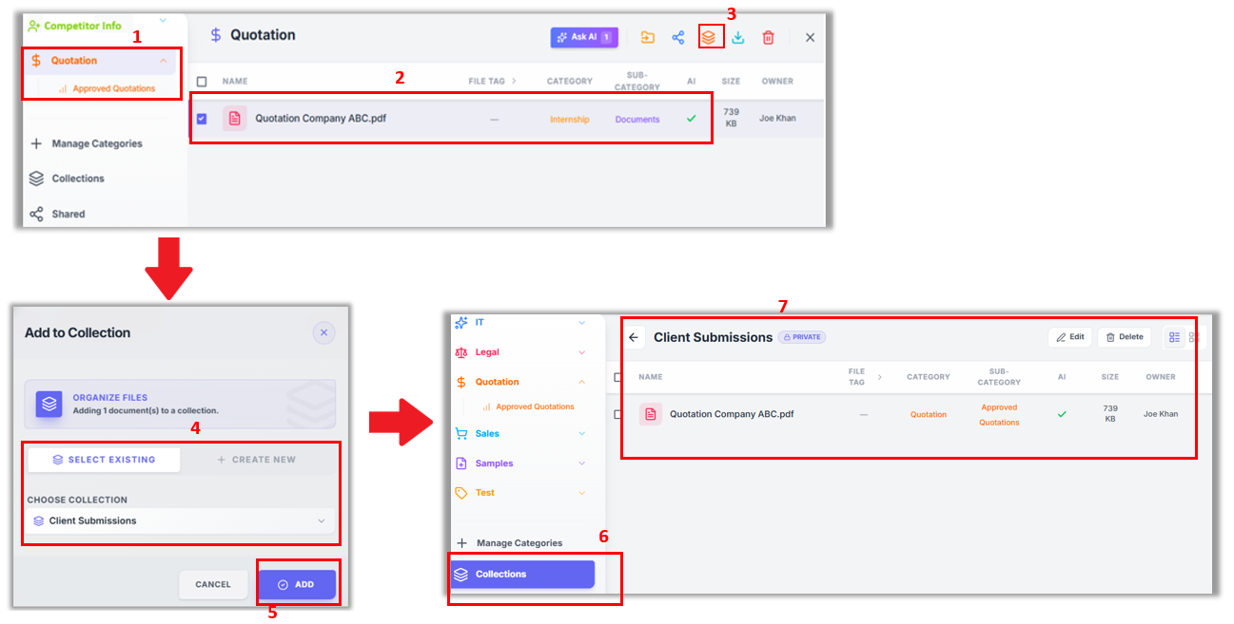

Deleting a Collection
- Click Collections.
- Tick the Collection you want to delete.
- Click the Delete icon.
- Type Delete.
- Click Delete to confirm.

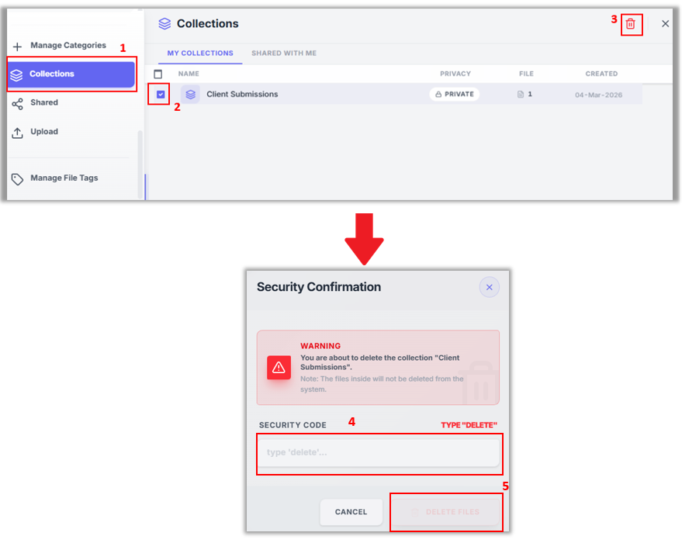

- Metadata and Tagging

Metadata allows you to attach additional information to documents.

This makes documents easier to search and helps the AI understand the content more accurately.

Example metadata fields for an invoice:
• Invoice Number
• Invoice Date
• Supplier
• Total Amount

Creating a File Tag
1. Click Manage File Tags.
2. Select Create New File Tag.
3. Enter a tag name.
Example:Invoice
4. Add metadata fields such as:
• Invoice Number
• Invoice Date
5. Click Create New File Tag.

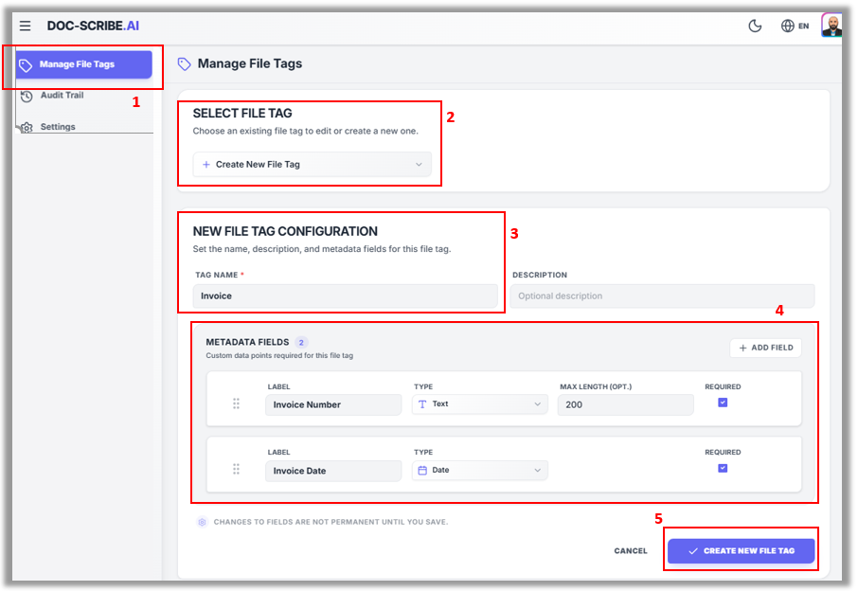

Once created, these metadata fields can be applied to documents.

Editing Document Metadata
- Navigate to the document.
Example : Quotation > Approved Quotations.
- Right-click the document.
- Select View/Edit Tag.
- Click Edit.
- Select File Tag.
Example: Invoice Number: INV1234
Invoice Date: 05/03/2026
  - Click Save Changes.

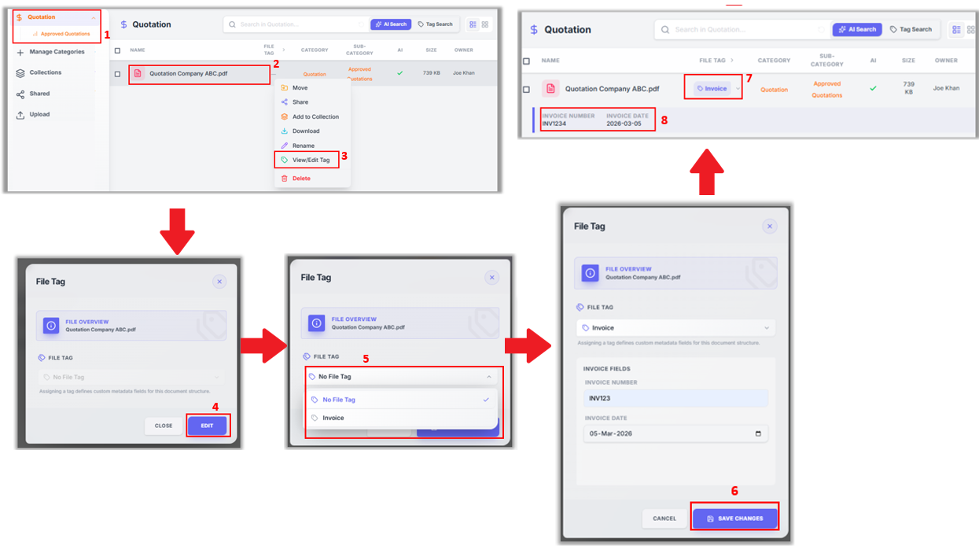

- Interacting with Chat AI

Chat AI allows users to interact directly with documents using natural language.

Instead of reading the entire document, you can simply ask questions.

Steps
1. Navigate to the document you want to analyze.
2. Select the document.
3. Click AI Search.
4. Enter your question in the Chat AI window.

Example queries:
• Summarize this document
• What is the total quotation value?
• List all suppliers mentioned
• Extract invoice numbers

The AI will analyze the document and return results instantly.

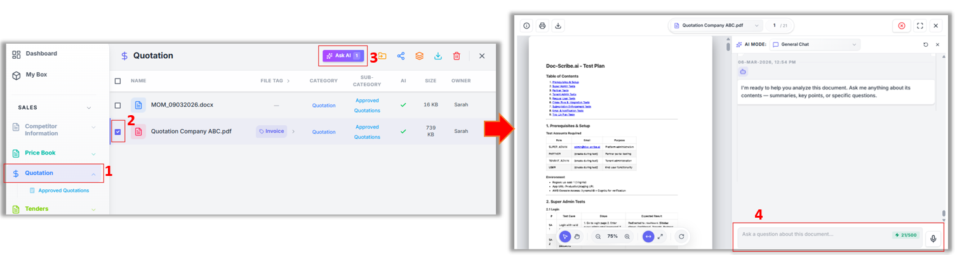

- Understanding AI Modes

Doc-Scribe provides several AI modes designed for different types of analysis.

General Query

Used for everyday questions and summaries.

Example: Summarize this document.

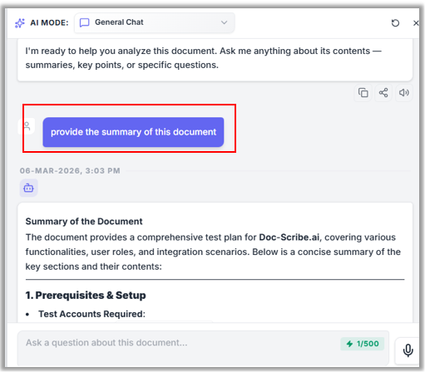

Visualizer Mode

Creates charts, diagrams, and visual summaries from document data.

Useful for:
• Reports
• Presentations
• Data analysis

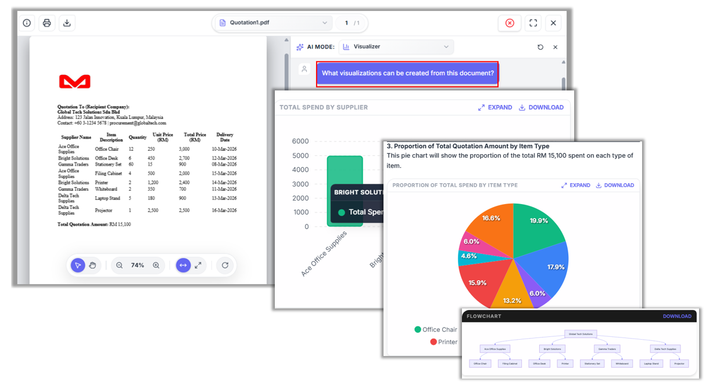

Analyst Mode

Performs deeper analysis and identifies patterns or inconsistencies.

Example: Compare supplier quotations.

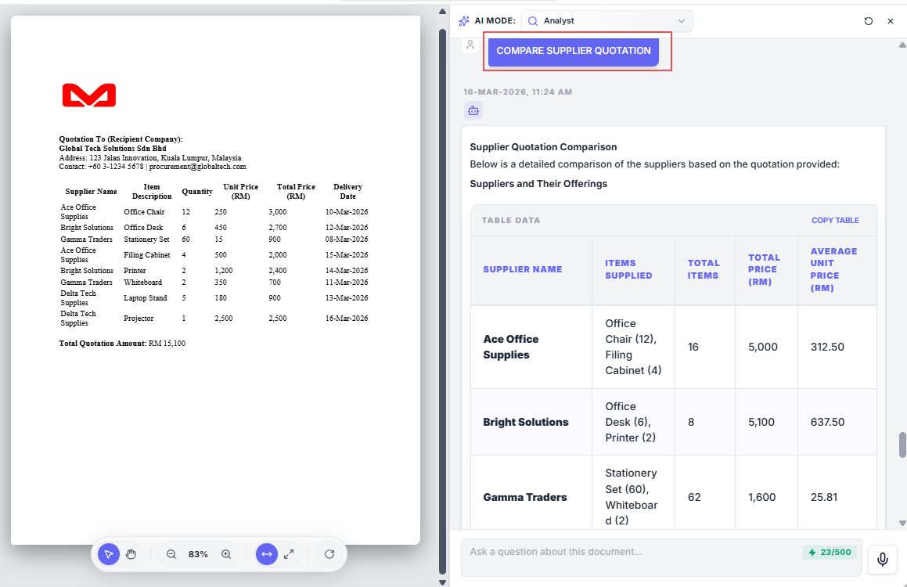

Reviewer Mode

Checks documents for errors, missing information, or inconsistencies.

Example: Check if there are calculation errors.

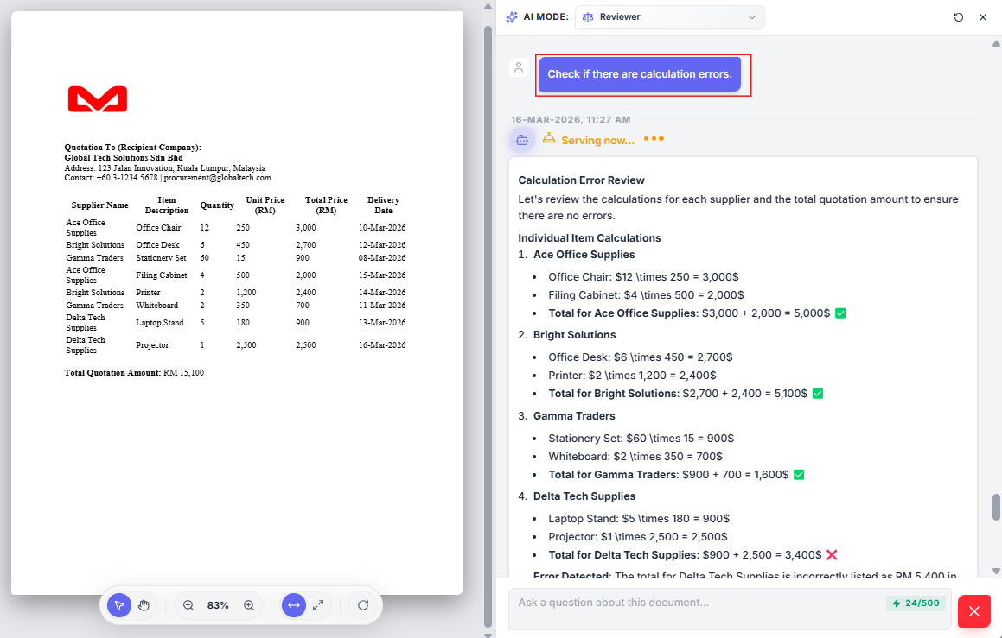

Transcript Mode

Analyzes meeting transcripts and extracts key information.

The AI can identify:
• Key discussions
• Decisions made
• Tasks assigned

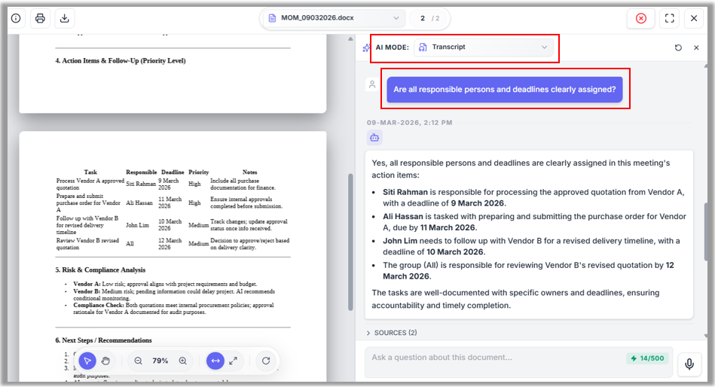

Extractor Mode

Extracts structured data from documents such as invoices or reports.

Example extracted data:
• Invoice Number
• Supplier
• Item details
• Total amount

This data can be exported into systems such as ERP or Excel.

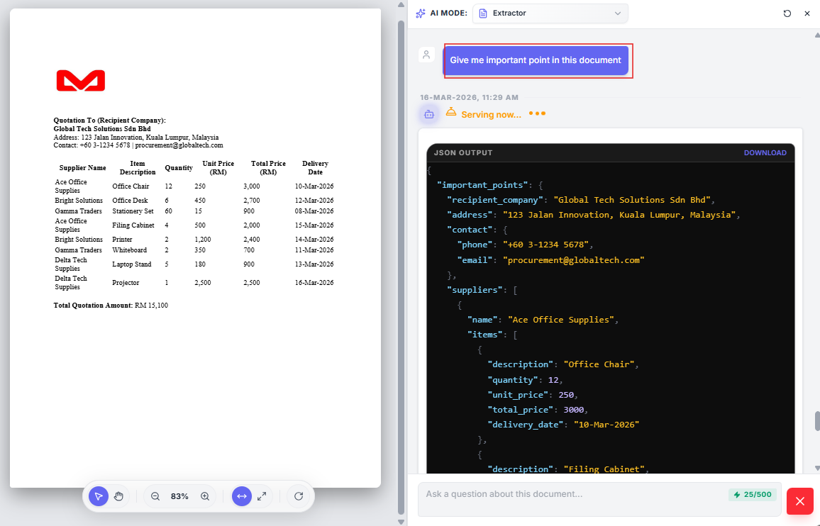

- Sharing Documents

Documents can be shared with other users or departments.

Steps
1. Open the document.
2. Click Share.
3. Select a user from the same department or another department.
4. Choose permission level.

Permission options:

Permission Description
Can View User can view and interact with the document
Can Download User can view and download the document

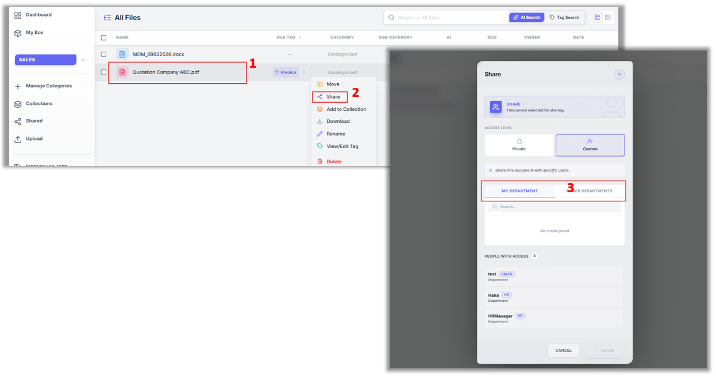
The shared document will appear in the recipient’s Shared With Me section.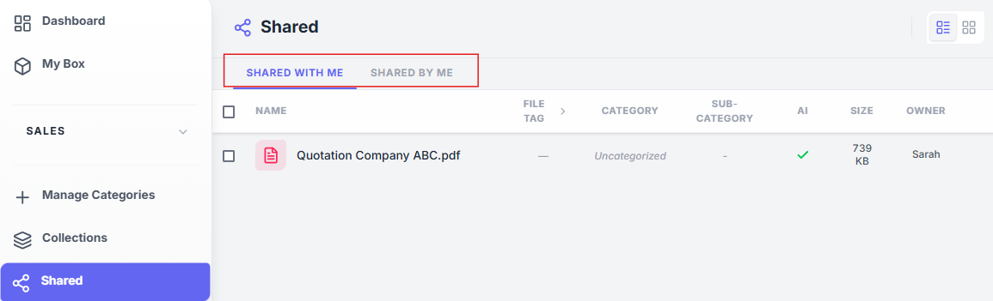

- Troubleshooting Common Issues

Cannot Upload Document

Check that:
• The file size is within limits
• Your internet connection is stable

AI Search Not Working

Ensure that:
• The document is selected
• The document has finished processing

Cannot Access Shared Document

Check that:
• The document was shared with you
• Your permission level allows access

Metadata Not Appearing

Refresh the page and ensure the document has been tagged correctly.

Document Not Appearing in Search

Check that:
• The document upload completed successfully
• The document has been indexed by the system.
• The correct keywords are used in the search.

Slow Document Loading

Check that:
• Your internet connection is stable.
• The document size is not very large.
• Try refreshing the page.

Unable to Create a Collection

Check that:
• You have the required permissions.
• The collection name is not already used.

Unable to Edit Metadata

Check that:
• You have edit permissions for the document.
• The File Tag has been created.
• The metadata fields are filled correctly before saving.

Notifications Not Received

Check that:
• Your email address is correct in your profile.
• Emails are not in your spam/junk folder

Unable to Delete Document or Collection

Check that:
• You have permission to delete
• The document or collection is not locked or in use by another user.

Login or Session Issues

Check that:
• You are using the correct account credential.
• Your browser cache is cleared.

Document Preview Not Showing

Check that:
• The document format is supported for preview.
• The document has fully uploaded and processed.

- Choose Your Language

Located in the top-right corner of the screen, look for the globe icon (🌐) followed by "EN". Click on it to open the language menu and select your preferred language for the entire platform. (Please refer Figure 12)

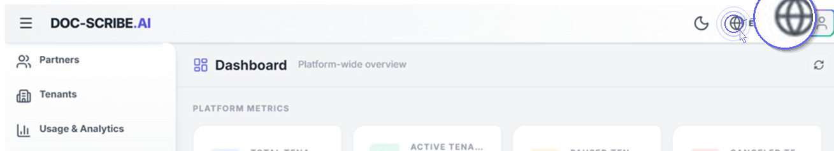

Figure 12

Supported languages: English (EN), Malay (MS), Chinese (ZH), Thai (TH), Hindi (HI), and Japanese (JP).
💡Tip: Your language preference will be saved automatically and applied throughout the entire platform.
- File Compatibility

Doc-Scribe.ai supports a wide range of file formats for easy upload and instant viewing. From documents and spreadsheets to drawings and email files, everything can be accessed in one secure platform.

No extra software. No compatibility issues. Just smooth and reliable file access.

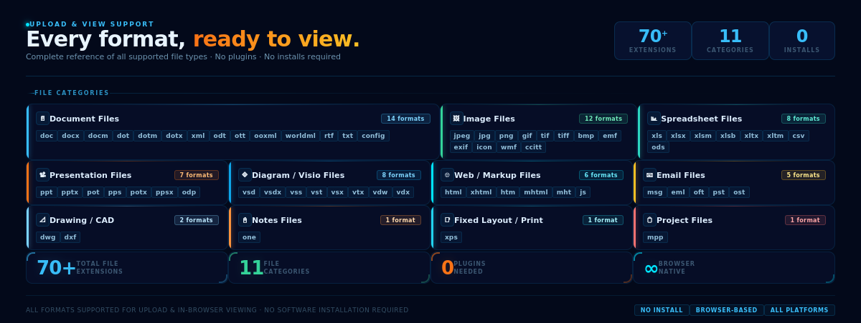

- User Access Control
With Doc-Scribe.ai, you are in control of what your users can see and do. When inviting a new user, simply choose the access that suits their role.
Global Access Want the user to see everything? Turn this on and they can view files across all departments — great for managers or admins who need full visibility.
Manage Categories Need someone to organize your files? Turn this on and they can add, edit, or remove file categories to keep things tidy.
Not sure? You can always update these settings later in User Management.
